Q. In how many ways can 7 people be arranged if two particular people must always be together? (2.5 Marks)
Solution:
Step 1: Let the two particular people be A and B. They can be arranged as AB or BA.
Step 2: Treat A and B as one block. Total units = 1 + 5 = 6
Step 3: Arrange the 6 units.

Step 4: A and B can be arranged within the block in 2! = 2 ways.


Permutation with repetition — Question 9
Question: Find how many ways you can rearrange the letters of the word BANANA all at a time.
Step 1: Count the letters.
BANANA has 6 letters:
- A appears 3 times.
- N appears 2 times.
- B appears 1 time.
Because some letters repeat, we divide by the factorials of their repetitions.
Formula:
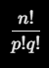
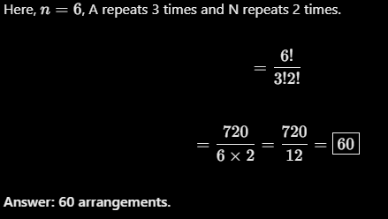

Permutation with repetition — Question 10
Question: Find the number of arrangements of the word BALLOON.
Step 1: Count the letters.
BALLOON has 7 letters.
- L appears 2 times.
- O appears 2 times.
- B, A and N each appear once.
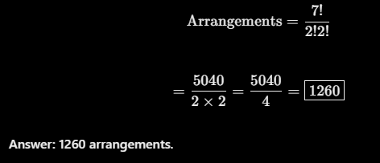

Q. 18 How many bit strings of length 6 contain exactly four 1s?
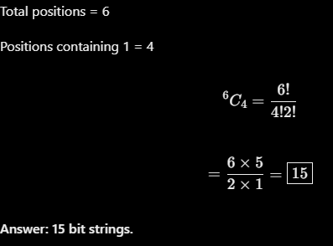
19) How many bit strings of length 8 contain exactly two 1s?
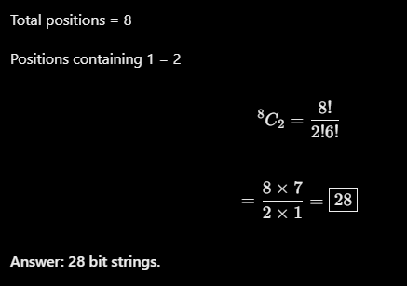
20) A binary message consists of 10 bits. Exactly 4 bits must be 1 and the remaining 6 bits must be 0. How many different messages are possible?
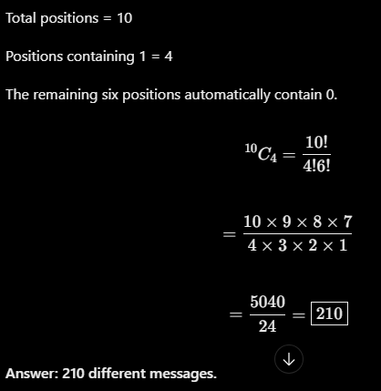

6. Combination with repetition — Question 23
23) A bit string contains 0s and 1s. How many ways can we select 5 bits if repetition is allowed and order is ignored?
There are two types of bits: 0 and 1.
- Number of types, n = 2
- Number of bits selected, r = 5
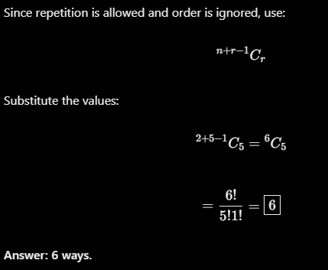

Permutation with repetition
7]
n = 5
r = 3
n^r = 5^3 =5*5*5 = 125

8]
n = 10
r = 4
n^r = 10^4 = 10*10*10*10 = 10000

Combination without repetition
nCr = n!/r!(n-r)!

1]
n = 5
r = 2
nCr = n!/r!(n-r)! = 5!/2!(5-2)! = 5!/2!3! = 5*4/2*1 = 20 /2 =10

2]
n = 5
r = 3
nCr = n!/r!(n-r)! = 5!/3!(5-3)! = 5!/3!2! = 5*4/2*1 = 20 /2 =10

3]
n = 12
r = 5
nCr = n!/r!(n-r)! = 12!/5!(12-5)! = 12!/5!7! = 12*11*10*9*8/5*4*3*2 = 792

4]
n = 18
r = 4
nCr = n!/r!(n-r)! = 18!/4!(18-4)! = 18!/4!14! = 18*17*16*15/4*3*2*1 = 3060

5]
n = 5
r = 2
nCr = n!/r!(n-r)! = 5!/2!(5-2)! = 5!/2!3! = 5*4/2*1 = 20 /2 =10

6]
n = 52
r = 5
nCr = n!/r!(n-r)! = 52!/5!(52-5)! = 52!/5!47! = 52*51*50*49*48/5*4*3*2*1 = 25,98,960

7]
n = 6
r = 3
nCr = n!/r!(n-r)! = 6!/3!(6-3)! = 6!/3!3! = 6*5*4/3*2= 20

8]
n = 6
r = 4
nCr = n!/r!(n-r)! = 6!/4!(6-4)! = 6!/4!2! = 6*5/2 =15

9]
n = 8
r = 2
nCr = n!/r!(n-r)! = 8!/2!(8-2)! = 8!/2!6! = 8*7*/2 =28

Combination with repetition
1]
n = 3
r = 4
^n+r-1 Cr = 3+4-1C4=6C4=n!/r!(n-r)!=6!/4!2! =6*5/2=30/2=15

2]
n = 4
r = 3
^n+r-1 Cr = 4+3-1C3 =6C3 =6!/3!3! =30/6=5

4]
n = 5
r = 4
^n+r-1 Cr = 5+4-1C4=8C4 = 8!/4!4!=8*7*6*5/4*3*2=2*7*2*5/2=70

5]
n = 3
r = 6
^n+r-1 Cr = 3+6-1C6=8C6 = 8!/6!2!= 8*7/2=28

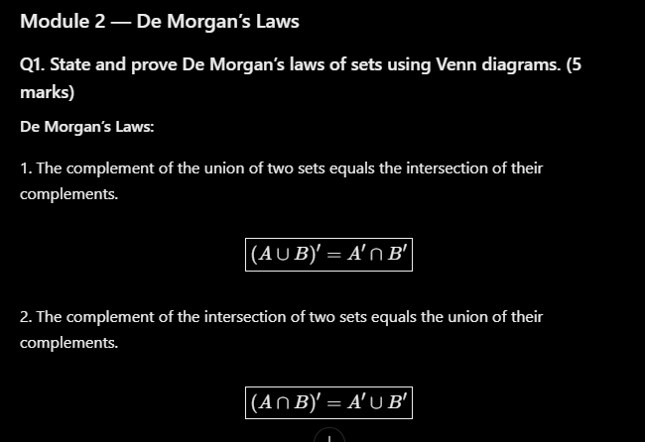
Proof using Venn diagrams:

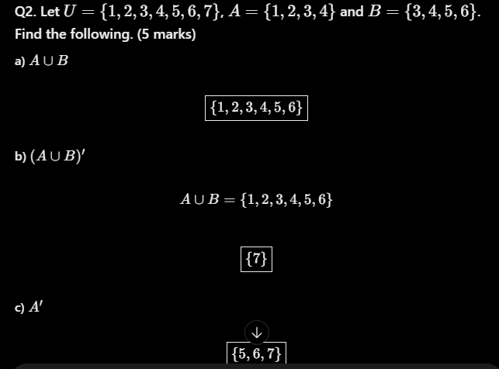
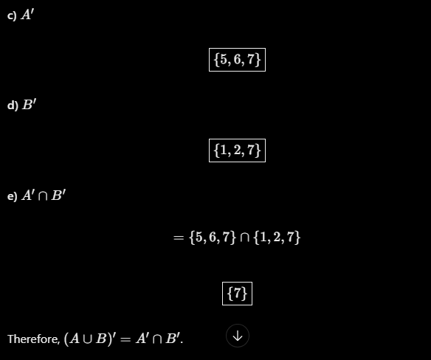
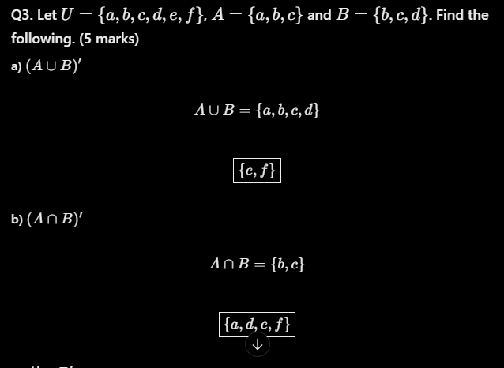
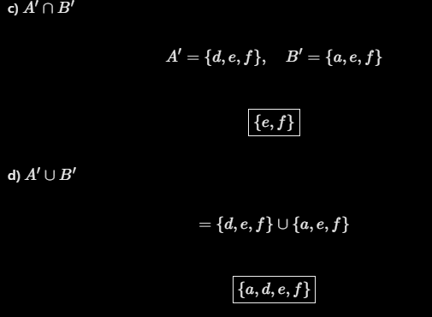
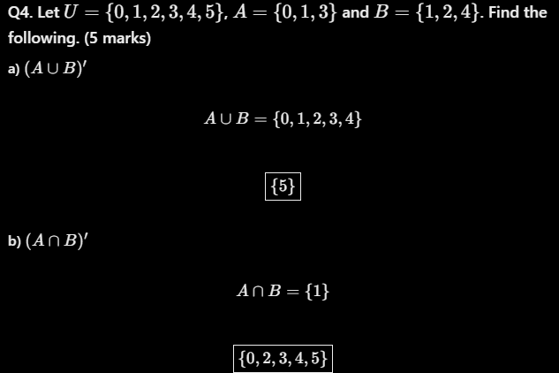
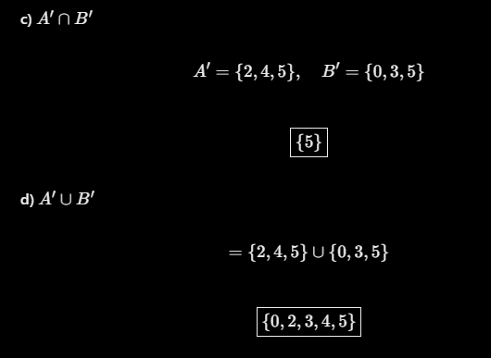
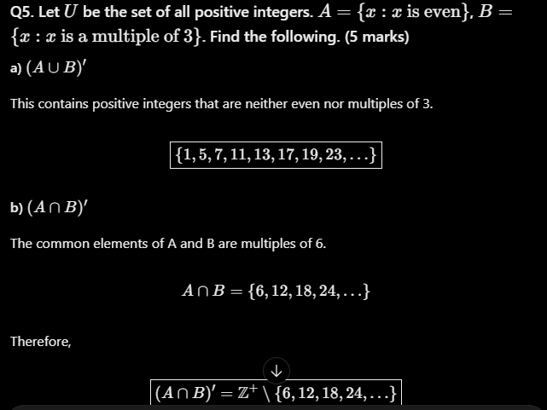

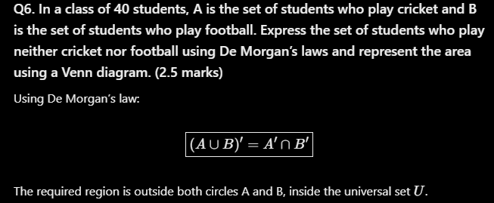
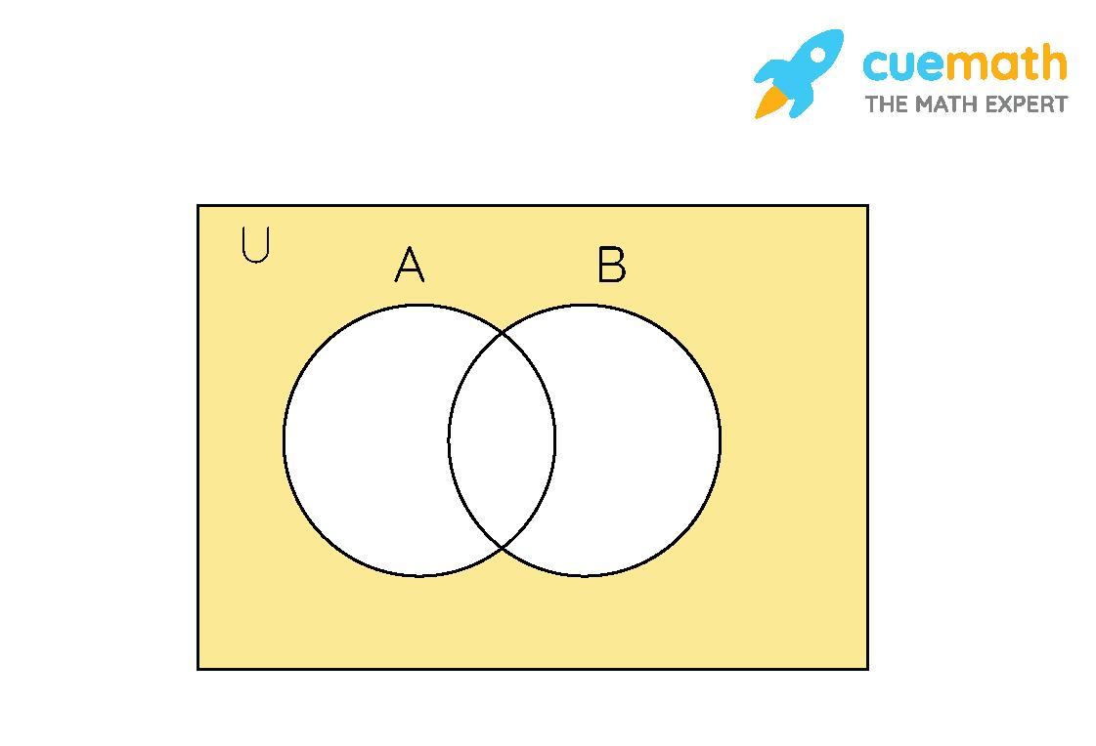
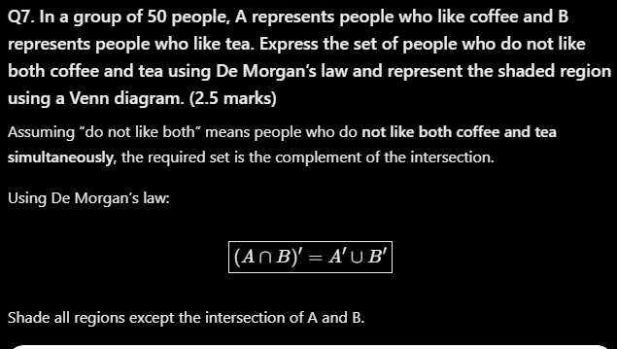
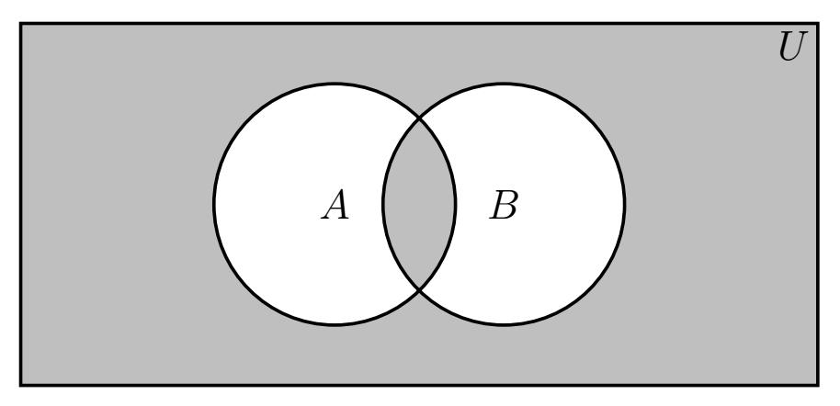

Q8. Let A be the set of computers with antivirus software and B the set of computers with a firewall. Express the set of computers having neither antivirus nor a firewall using De Morgan’s law and represent the shaded region using a Venn diagram. (2.5 marks)

Using De Morgan’s law:




